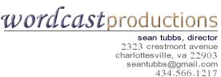

# *ESTIMATE for recording and production services*

3/7/2011

To: **Althea Brooks**, Alumni Education

Office of EngagementUniversity of Virginia

Specifics:

* + Record event at UVa Art Museum on May 24, 2011
  + Post audio to iTunes U

**Wordcast Contract #:** UVA857767

The cost of recording this events is $150

Details:

Sean Tubbs or an associate will arrive at the UVA Art Museum at 5:15 to set-up. Prior to the event, he will make sure he can plug his audio device into the in-house PA system. He will record the event, and produce it as soon after the event as possible.